SC2107 Lab2 Assignment Sheet (to be submitted to NTULearn before next lab)

Name: Jothilingam Dheeraj Lab Group: SCE3 Date: 9/10/24

- Section 6.2. Give a short 2-3 lines description on concept behind the reflectance reading process. Why does the black surface result in slower voltage decay?
Ans: Reflectance sensors detect light reflected from surfaces to differentiate between black and white areas. A black surface reflects less light compared to a white surface, resulting in a slower decay of voltage on the sensor's capacitor, which makes the black surface take longer to register.

- Section 6.2. Which parameter do you need to tweak in the Reflectance_Read() if the reflectance sensor reading is not accurate? Hint: check the 8 steps for Reflectance reading.

Ans: The parameter you need to adjust is the waiting time before reading the sensor values. This time determines how long the sensor waits for the capacitor to discharge and fine-tuning it can help improve accuracy in distinguishing between black and white surfaces.
- Section 6.2. Write down the procedure to initialise P7.3 to be an input pin without internal pull-up resistor

Ans: This is procedure to initialise P7.3 to be an input pin without internal pull-up resistor
P7->SEL0 &= ~0x08; // Set P7.3 to GPIO mode
P7->SEL1 &= ~0x08; // Set P7.3 to GPIO mode
P7->DIR &= ~0x08; // Set P7.3 as input
P7->REN &= ~0x08; // Disable pull-up resistor
P7->OUT &= ~0x08; // Clear output register

- Section 6.3. Where are the sources of the offset error between actual distance and the estimated distance return by the function Reflectance_Position()?

- Ans: The main causes of offset error between the actual and estimated positions could include misalignment of sensors, variations in surface reflectance, and the mathematical model used to calculate the position. The position calculation relies on weights assigned to each sensor, so any slight deviation in the physical setup or environment can introduce errors. The weights assigned to each sensor in the array W[8] is also another cause

- Section 7.2. Figure 7. The robot state toggled between LEFT and CENTER state repeatedly when it is detected that the robot is off to the left of the line (input: ‘01’). If the outputs of the FSM states are connect to the input of the DC motor, how would the input signals to the DC motor looks like? Which wheel will move at a slower speed?
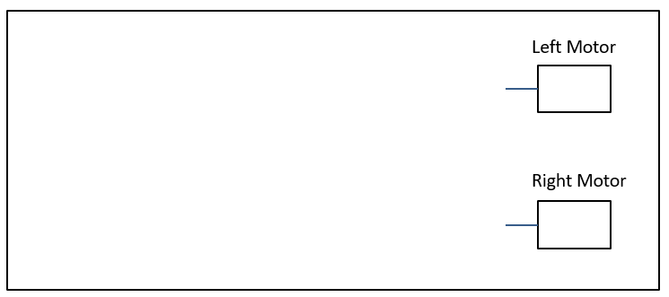
Ans: The robot's left motor slows down when it switches between LEFT and CENTRE, whereas the right motor has a longer duty cycle that enables the robot to return to the centre. As a result, the left motor runs more slowly than the right.

- Section 7.3. Fix the bug in the 11-state FSM design.
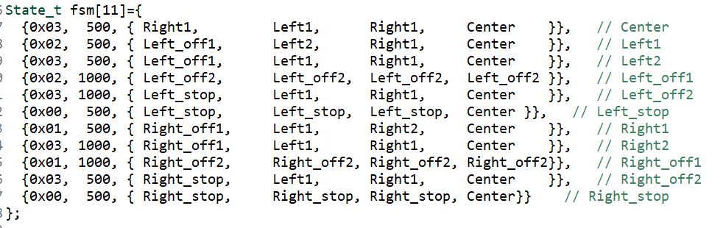

Ans: To fix the bug where the FSM continuously toggles between certain states, you can introduce hysteresis. This means adjusting the state transitions so the robot doesn't switch states until a significant change in input is detected. This will help reduce oscillation and create smoother movement. Thus, the following adjustments need to be made: Right2 = 500 Right_off2 = 1000. By altering their values to 500 and 1000 milliseconds, respectively, the appropriate motor will have more time to adjust the robot's position.

- Section 7.3. What is the purpose of toggling LED within the main routine or ISR?

Ans: Toggling an LED acts as a visual indicator that the system is running. It can be used for debugging purposes to show that the main loop or ISR is functioning correctly.

- Section 7.4. What hardware and software modifications are required in order for the robot to move within a lane, i.e. between two black lines, instead of following a line? Detail algorithm not required. Just one bullet point each for hardware and software.

Ans:
  - Hardware Modification for Lane Following: Add additional reflectance sensors to detect both left and right boundaries of the lane, allowing the robot to stay within two lines instead of just following one.
  - Software Modification for Lane Following: Modify the FSM to account for two lines, adjusting the motor control logic to maintain the robot within the lane by keeping track of both boundaries.

